Title
Faegan White – Student No.

Introduction
- Description of the problem
- Overview of my solution approach
- Approach with 3 aims
  - Develop a genetic algorithm for data mining
  - Compare the performance with a Social Spider algorithm for comparison in data mining
  - Extend the capabilities of the data mining algorithm in order to create a solution which finds the minimum number of rules for an optimal solution

Background Research
- Basics of a genetic algorithm
  - Genome, mutation, crossover ect.

SHOW US A NICE OLD PROBLEM SURFACE?

Experimentation
Explanation of a Data Mining Algorithm
- What is data mining?
  - Data mining is the process of finding anomalies, patterns and correlations within large data sets to predict outcomes (citation needed)
  - In our example, the data set consisted of a list of entries, each with a set of properties (represented as value between 1 and 0) and a class it belonged to, represented with either 1 or a 0
  - The task was to train an algorithm to learn which properties make up which class, so that it could sort unseen items with a high classification accuracy
- How does my algorithm work?
  - The basis of the algorithm is the same as described in the background research section aka. A standard genetic algorithm core
  - However, in order to fit the design for data mining, it needs to be able to determine patterns within the data
  - In order to achieve this, the genome is used to represent a set of rules, where value pairs are used to represent the bounds for which a property value must fall between
  - e.g. a pair 0 and 1 will accept any value, whereas the pain 0 and 0 will never accept a value
  - Each rule is made out of as many pairs as required – 1 for every property of the data plus an extra value to represent the outcome of the rule which is either a 1 or a 0
  - Hence the rule size is always 2n+1 where n is the number of properties of the data being sorted
  - A genome can be made out of any number of rules, hence can have any length
  - More rules mean more chance to correctly identify an item (check this with brain) but leads to greater overfitting as every rule may come to represent data
  - Less rules mean a more general matching ability but too little may be unable to properly capture the complexity of the data set

Example genome> diagram me as a rule:

0.2569752244532422, 0.7677804675200207, 0, 1, 0, 1, 0, 0.6888602357571432, 0, 0.15995737319298753, 0.26000303037706174, 0.9649481569648961, 0.07749397011045515, 0, 1, 0.44498009030002783, 0.7364319508474593

- What are the parameters of the algorithm?
  - As the algorithm is developed, more parameters are added to allow more control to the every-increasing complexity
  - The original parameters in my code are…
    - max_val – the maximum value in a genome
    - min_val – the minimum possible value in a genome
    - population_size – the number of solutions in any given generation
    - generations – the number of generations
    - rule_number – how many rules make up the genome
    - tournament_number – how many individuals are used in tournament selection
    - mutation_chance – the chance of any value in the genome mutating for every individual in each generation of the algorithm
    - mutation_amount – the maximum amount the value in the genome can change by when mutating
    - repeat_times – number of times to repeat the entire algorithm in order to create a more reliable, averaged result
  - Completed a sweep of the data, here is an example for 11 rules on data set 1 looking at how mutation chance and mutation amount affect the algorithms fitness
  - The sweep compared mutation chance, mutation amount and rule number for data1.
  - Data from the sweep for data set 1, 2 and 3 can be found in the appendix
  - Mapped onto a 3d surface to show the relationship between mutation chance and mutation amount. It is clear that a mutation rate of 0.12 and a mutation amount of 0.8 were optimal for 11 rules
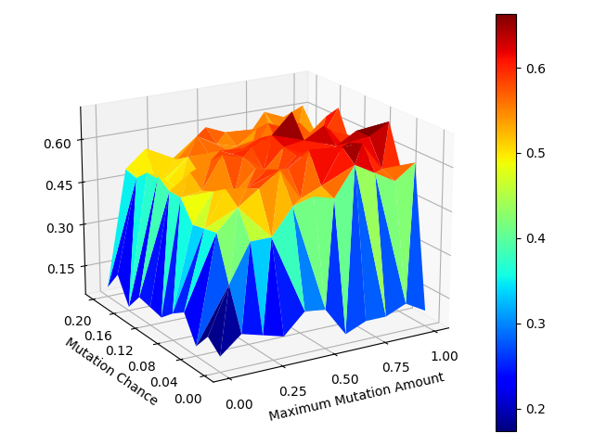

- What is the fitness function?
  - The fitness function of the algorithm is the number of items from a given list that an individual solution can successfully predict the class of
  - This is done by feeding every item from the list through each rule of the individual
  - When a rule is successful, it will increment the fitness counter and move onto the next item of data
  - If the item of data isn’t successfully predicted by any rule, the fitness counter wont increase
  - hence the fitness is the total number of data that can be classified successfully
- Could someone replicate it from this description?
- What were the results I achieved?
  - In order to find the best results, I did some initial experiments. Here are the results for the 3 data sets…
  - I then ran some parameter sweeps to determine the best parameters to give the highest fitness in the shortest space of time (check with brain)
- How did the performance change when parameters changed? - with examples
  - Changing the population number allowed the testing of more solutions concurrently, and hence finding optimal solutions in fewer generations but with more compute. Also less likely to get stuck in a local optimum with a larger range of solutions
  - The generation number allowed increased convergence on a higher fitness at the cost of time taken. This was especially relevant with data set 2 and 3 which required many more generations to achieve fitness over 80% but took a long time to run – could speed up by using a different platform such as C++
  - More rules meant more compute power and time as a larger genome needed to be processes but allowed for better representation of the data. It is especially clear that too few rules are unable to correctly classify the data

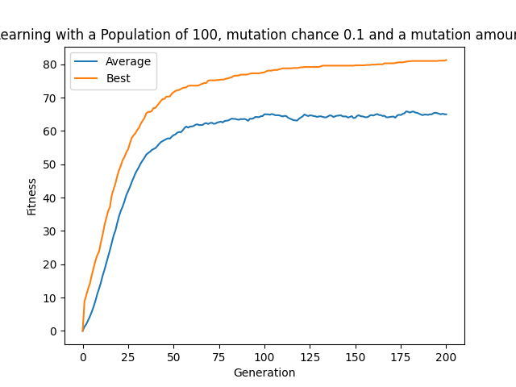

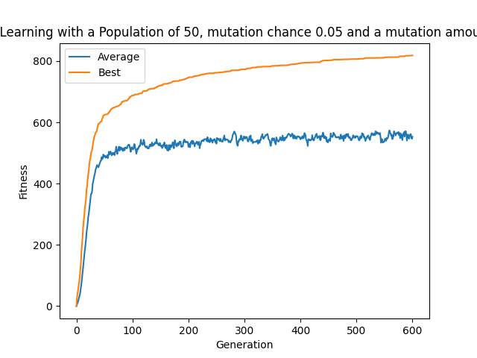
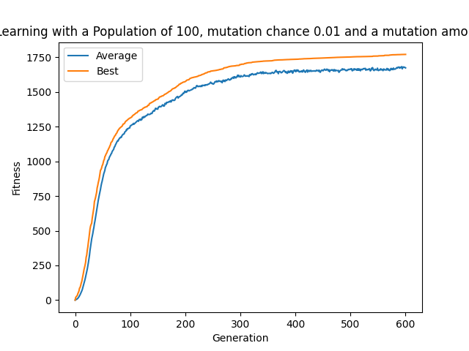

K-fold validation
- Why implement K-fold validation?
  - An issue with the system described above is that when implemented, an algorithm will be classifying data it has never seen before, not data that it has been trained on
  - In this regard, it is important to test the solutions using unseen data in order to gauge its actual effectiveness
  - A classical way to approach this is to divide the data into 2 sections, one for training and one for testing
  - However 2 problems arrive, how do you determine what ratio is appropriate and how do you ensure you don’t miss what could be important inferences from the testing set of data?
- How does it work?
  - An approach to overcome this is K-fold validation
  - This splits the data into K defined sections, and then tests 1 after training with the remaining K-1 sets
  - This process repeats K times, taking an average of the accuracies at the end to use as the final accuracy of the solution
  - This ensures that the algorithm is trained and tested on every piece of data, giving a much broader, more confirmed view of the accuracy of the solution for implementation
- How did it affect the accuracy?
  - Ultimately, this reduced the apparent accuracy if the algorithms as shown in table X
  - It would appear that the larger the data set, the less affected it is by k-fold validation
  - This is because the less data in the data set, the less likely the rules are to learn the general classifications to separate them
  - On top of this, k-fold validation reduces the size of the training data set which has a disproportionately negative effect on smaller data samples
- What does this mean? Overfitting/underfitting?
  - Could mean that the algorithm is overfitting data1, a common effect of a small data set
  - Evidence to show this
- Were all data sets affected the same?

 | Data1 |  | Data2 |  | Data3
 | Training | Testing | Training | Testing | Training | Testing
1 | 0.82 | 0.57 | 0.8 | 0.76 | 0.87 | 0.84
2 | 0.82 | 0.58 | 0.8 | 0.78 | 0.87 | 0.84
3 | 0.81 | 0.6 | 0.78 | 0.73 | 0.89 | 0.85
4 | 0.84 | 0.62 | 0.81 | 0.77 | 0.86 | 0.85
5 | 0.82 | 0.58 | 0.82 | 0.8 | 0.89 | 0.85
6 | 0.81 | 0.54 | 0.82 | 0.8 | 0.87 | 0.85
7 | 0.83 | 0.72 | 0.82 | 0.78 | 0.89 | 0.86
8 | 0.83 | 0.61 | 0.8 | 0.77 | 0.87 | 0.84
9 | 0.8 | 0.55 | 0.82 | 0.78 | 0.87 | 0.83
10 | 0.82 | 0.53 | 0.82 | 0.8 | 0.87 | 0.86
Average | 0.82 | 0.59 | 0.81 | 0.78 | 0.88 | 0.85

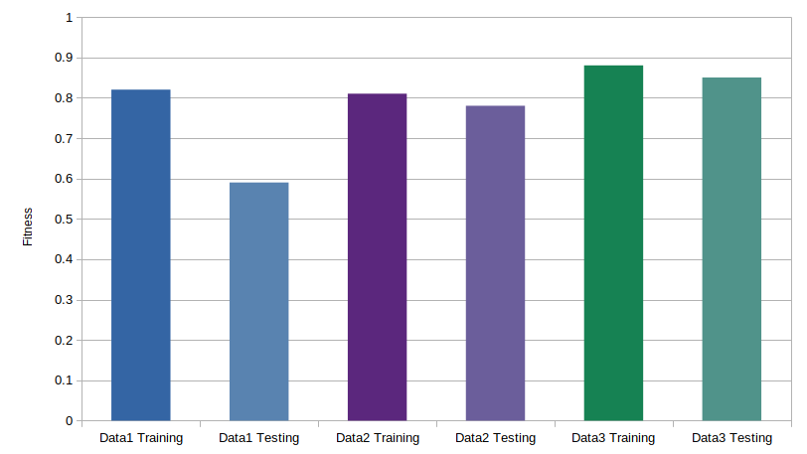
This bar chart shows the comparison of K-fold validation for the 3 data sets. It’s clear that the the larger the data set, the higher the training accuracy, testing accuracy and the smaller the difference between training and testing.

This suggests less overfitting on the larger data sets, which corresponds with the research of (citation needed) which poses that less data increases overfitting as the model becomes more specialised

Comparison with Social Spider Algorithm

- After the success of implementing the genetic algorithm for use in data mining, I decided to implement the Social Spider Algorithm in order to determine a comparison in performance
- This was done by obtaining the Social Spider Algorithm source code from site X and transferring the fitness function from the genetic algorithm into the code.
- Represented the problem space becomes a 35 dimensional web, where the position in 2 dimensions make up 2 boundary values. 6 pairs together make up a rule, with a 13th dimension being used to represent the output of the rule when rounded to either 0 or 1
- This produces 5 rules to train against the data, so that each spider can become a heuristic to sort the results.
- The inputs to the algorithms were
  - dimension – number of values, same as length of genome
  - Spider number
  - epochs
  - r, c, a
- What values did I try and what was the affect?
- Initial results, mapping the performance of a small number of spiders shows that the algorithm tended to get stuck at a fitness of 52: a local minimum which is the highest fitness that can be achieved with a single rule on data1
- It also shows the large number of epochs required compared to the genetic algorithm, suggesting the ability to explore the search space or exploit the current value isn’t as effective as the GA
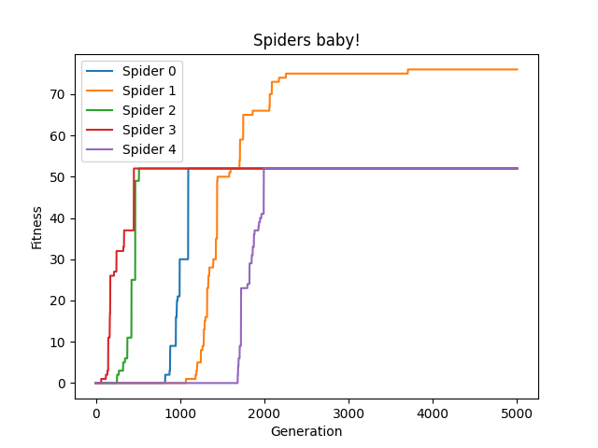
The plot of average fitness and best fitness averaged over 10 runs of the algorithm develops this point further, that although successful locations in the web are discovered, the spider movement is unstable and unable to converge on the optimal solutions to the nuance of the 35 dimensional space
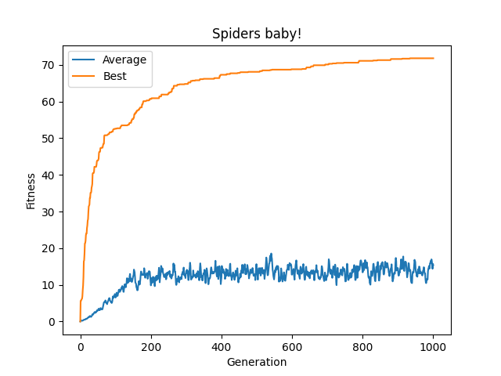
- A comparison of the genetic algorithm compared to the SSA clearly shows that the rate of fitness increase in the SSA is slower and it is unable to reach the same level of accuracy that the GA reaches.
- Both algorithms are using 5 rules with a population of 100 solutions
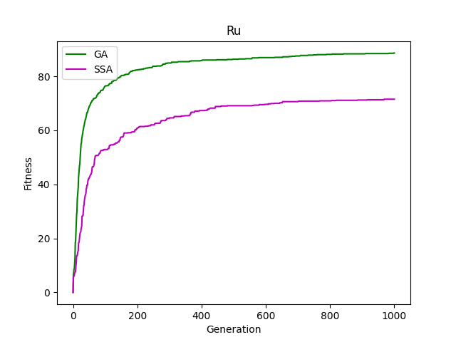

Variable Genome
- Why implement a variable genome?
  - Ultimately, as a user it isn’t possible to find the best number of rules to represent the problem without a parameter sweep to gain knowledge over the problem domain
  - This takes resources and time to perform, especially if you want to get intricate repeatable results
  - If the rule number is too small it may not have sufficient scope to effectively model the problem space
  - And if the rule number is too large, then the solution will begin to overfit the problem which will be both a waste of computing resources and could lead to inaccurate results when the testing data is different to the training data (citation needed)
  - Hence, letting the algorithm evolve its own gene size while calculating solutions is an efficient use of computing power, generating solutions with the greatest balance of accuracy and complexity without costly parameter sweeps of the required rule size
- How does it work/what does it represent?
  - In order to implement this, I first needed to change the crossover method to be able to handle variable length genomes
  - My previous method would simply pick a random point in the genome length, and then take one half from each parent on opposite sides of the genome and place these together.
  - The problems with this are that a random point in one genome may be beyond the range of the smaller genome’s length
  - The solution to this is to always pick a random point in the smaller genomes length to use as the crossover position, however this too leaves a problem.
  - Picking a single point in the smaller genome and combining it with the remainder of the larger genome creates a bias towards forming larger or smaller genomes depending on which genome is picked first.
  - To get around this, the crossover function generates too solutions, one longer and one smaller using 2 alternating sections from both parents and then randomly decides between them to use as the child’s genome
  - This functioned correctly, but led to ever increasing genome lengths as there was no cost on rule number, which ultimately gave the algorithm poor performance. To solve this problem, I experimented with a number of techniques to add a cost to more rules and balance this with accuracy
  - I also had to add a new mutation feature, which given a defined chance, would either add a new random rule onto the end of the individuals genome or subtract the end rule from the genome of the individual
  - this ensured that new genes were being tested which are longer and shorter, so that they can be compared and new solutions of different sizes found
- What different ways did I implement it?
  - Fitness function – affected the fitness duh
  - included gene size as a factor of tournament selection, worked but needed a lot of complex tweaking to define the right balance so as to not prioritise one over the other in a wrong context e.g. used fitness**2/gene size
  - Later would always prioritise the fitness, unless it was equal (tournament selection) then would choose the answer with the lowest gene size – this had too small of an effect, played a large role in the initial couple generations as many finesses were equally low however at a later date the fitness was more varied and very few fitnesses matched the best solution so it would tend to stay high with fewer and fewer drops in rule size. Wouldn’t stabilise on the same rule number from different stating points
  - Finally used a blend of the 2, would prioritise fitness unless it was in a certain range of the other solution, then the one with the lowest gene would win. This allowed the control of the balance between the 2 variables with a single parameter: range & allowed the generation of solutions with an truly optimal number of rules to balance fitness and efficiency
  - Add the rule_size_factor to control the preference between accuracy and gene length
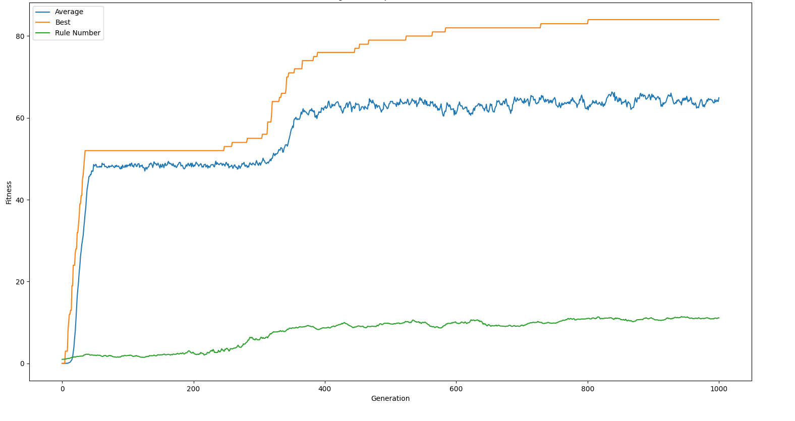

- How did it affect performance? Accuracy and efficiency
  - When poorly tuned, this would slow down the algorithm as it would tend to increase the rule size as there is no cost to the system for doing so
  - This is because there was no cost for more rules, whereas fewer rules are more likely to be unable to properly categorise the problem leading to lower accuracy and hence a bias towards more rules
  - However, once this value was properly tuned it was able to find the most efficient solution to the problem. A balance between simplicity – small rule number and accuracy.
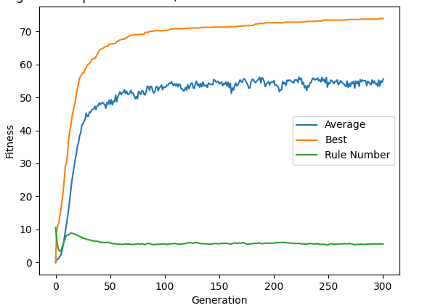

Table shows training on data1, where the average number of rules is 6 and the average fitness is 0.74. It is clear that higher fitness can be achieved by the algorithm when defining its own rule number, however sometimes it gets stuck at the local minimum of 0.52 with a single rule defining the algorithm. This is the same local minima that affects the performance of the social spider algorithm

 | Training | Rule Number
1 | 0.78 | 12
2 | 0.89 | 5
3 | 0.52 | 1
4 | 0.82 | 10
5 | 0.68 | 9
6 | 0.52 | 1
7 | 0.83 | 7
8 | 0.72 | 7
9 | 0.76 | 3
10 | 0.87 | 6
Average | 0.74 | 6.1

- What does it allow? Find the simplest, broadest solution
  - Ultimately
- How were different data sets affected?
- Did the results match my experiments in pt 1?

- How did I know that the correct rule number was being found? Aka the lowest number of rules to successfully manage the problem
  - repeat tests using different parameters until the same problem always found the same number of rules in a solution given enough time
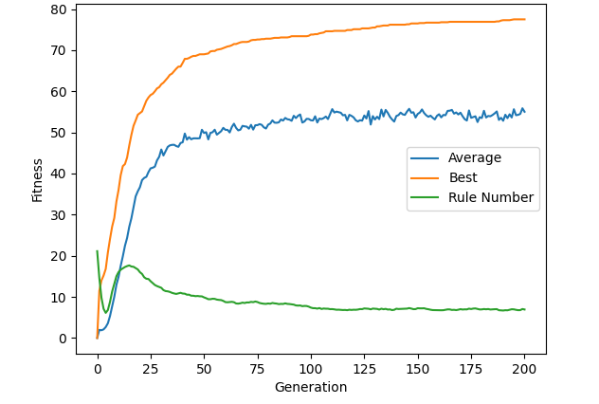
This tests show that the algorithm was successfully converging on an optimal solution as defined by the parameters set out by the algorithm. This is done by increasing the maximum rule number to 40, where the algorithm still converges down to the same fitness and rule number as a starting point of 20 rules during training

Nested Cross Validation training – AKA GENOME COMPRESSION
- Why implement n cross validation?
  - I decided to experiment, combining techniques from DNNs to evolutionary algorithms in order to find an alternative to the problem of the rule number optimisation
  - I found out about nested k-cross validation, a technique used for hyper parameter optimisation which works by splitting each epoch of training into k number of folds, then testing each fold using a different value for the hyperparameter
  - Then the network produced in the fold with the highest accuracy is used in the next generation, allowing the hyperparameter to become part of the model being trained
- How does it work?
  - I took inspiration from this concept, modifying my algorithm to split each generation into a user defined number of folds, each one taking the population from the previous generation and modifying every individual to have a proportion of the total number of rules according to k
  - The fold with the highest accuracy or equal accuracy but a smaller rule number was then used as the the starting population for the next generation
  - If this generation didn’t achieve a solution with higher accuracy or a smaller rule number, the algorithm will use a new population with 2 more rules than the generation previously
  - This acts to stop the solution converging on the most efficient accuracy to rule ratio → a single rule can obtain an accuracy of 52% for data1, keeping new solutions being tested and preventing complete loss of genetic information
  - Can achieve an accuracy of 70 with only 2 rules
  - One key problem with this solution was that changing the genome length every generation lost a lot of genetic information on a population level aka. A population with 10 rules per individual, then trimmed to 3 rules for the k fold test may loose all of its functionality, causing the accuracy of the algorithm to often get stumped
  - In response to this, I made a genome compression algorithm, which preferentially removed rules that had no classifying ability in the genome before those that classified the data and hence provided fitness to the algorithm
  - This means that when removing rules, those which perform the least categorisation and hence are the least prominent in a solutions accuracy are removed first
  - This allows genomes to be compressed down much smaller and faster with a reduced affect on the accuracy of the solution
- How did it affect the accuracy?
  - This was very successful, creating an accuracy comparable to the standard training algorithm but with a greatly reduced rule number of 4 only 4 rules
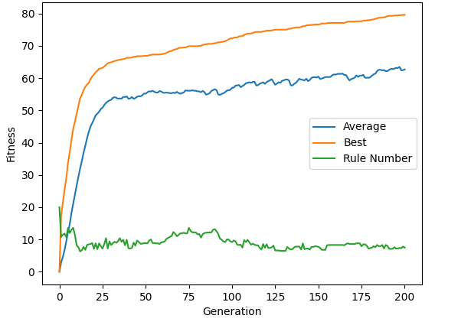

- What does this compare to the variable genome?
  - Ultimately this attempt to deal with discovering the correct rule number is hard to tune how much the genome size vs the accuracy should be favoured
  - The rule adjustments work on a population level compared to an individual level of the variable genome, this means that more genetic information can be lost when the number of rules diminish
  - However, the rule compression system means the the solutions produced by NKCV are reduced in complexity and tend to have less rules – this means that the results are easier to analyse and hence could be a better tool for manual analysis of the data using rules produced
  - Ultimately, the NKCV requires a lot more compute power, for every generation it needs to run through every fold with a different rule number
  - Adds another layer of complexity – more splits means more accuracy as it can test more rule numbers but takes even more compute power
  - This means variable genome is better for tasks where performance is important, NKCV may be more useful when explanation of results or lower complexity, lower accuracy heuristics are preferred
  - No rule_size_factor means there are less parameters to select when setting up the algorithm, this is important as the rule_size_factor must be tweaked to get good results when evolving the rule number and hence is more work for the user

 | Evolution |  | Compression
 | Training | Rule Number | Training | Rule Number
0 | 0.78 | 12 | 0.84 | 4
1 | 0.89 | 5 | 0.76 | 21
2 | 0.52 | 1 | 0.82 | 4
3 | 0.82 | 10 | 0.75 | 7
4 | 0.68 | 9 | 0.75 | 21
5 | 0.52 | 1 | 0.84 | 4
6 | 0.83 | 7 | 0.86 | 4
7 | 0.72 | 7 | 0.82 | 4
8 | 0.76 | 3 | 0.73 | 2
9 | 0.87 | 6 | 0.79 | 4
Average | 0.74 | 6.1 | 0.8 | 7.5
Std. Dev. | 0.13 | 3.7 | 0.05 | 7.21

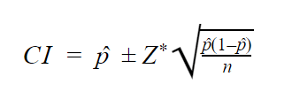
Formula for confidence interval:

 | Evolution |  | Compression
 | Training | Rule Number | Training | Rule Number
0 | 0.78 | 12 | 0.84 | 4
1 | 0.89 | 5 | 0.82 | 4
2 | 0.82 | 10 | 0.75 | 7
3 | 0.68 | 9 | 0.84 | 4
4 | 0.83 | 7 | 0.86 | 4
5 | 0.72 | 7 | 0.82 | 4
6 | 0.76 | 3 | 0.73 | 2
7 | 0.87 | 6 | 0.79 | 4
Average | 0.79 | 7.38 | 0.81 | 4.13
Std. Dev. | 0.07 | 2.88 | 0.05 | 1.36

These results were consistent for the other 2 data sets as well, producing a training accuracy akin to that of the standard genetic algorithm with a rule number greatly reduced to only 4 rules. This is also likely to reduce overfitting and thus improve performance when classifying unseen data – although this is yet to be tested.
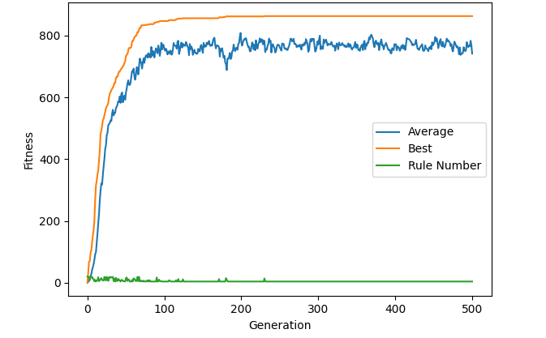
The genome compression technique could be combined with the rule evolution method to produce a blend of these 2 approaches, improving performance and rule compression ability of the algorithm.

Deciphering the genome
- Why do we need to analyse the genome?
- What insights could that give us?
- From the genome compression technique, I have pulled a 4 rule genome with very high training accuracy...
[0.2569752244532422, 0.7677804675200207, 0, 1, 0, 1, 0, 0.6888602357571432, 0, 0.15995737319298753, 0.26000303037706174, 0.9649481569648961, 0.07749397011045515, 0, 1, 0.44498009030002783, 0.7364319508474593, 0, 1, 0.5200849129225364, 1, 0, 0.25707352320440807, 0, 0.9557817431268466, 0.32577905218928643, 0, 1, 0.15480047310444878, 0.9357823727920461, 0, 1, 0, 0.8869180910372175, 0, 1, 0.004498101765539553, 1, 0.5669909776062353, 0, 0.9356717669425502, 0, 1, 0, 1, 0, 1, 0.03160604062202066, 0.4200950638805167, 0.6591731387680398, 1, 0.6906413877321006]

[0.25, 0.76, 0, 1, 0, 1, 0, 0.68, 0, 0.15, 0.26, 0.96, 0.07,
0, 1, 0.44, 0.73, 0, 1, 0.52, 1, 0, 0.25, 0, 0.95, 0.32,
0, 1, 0.15, 0.93, 0, 1, 0, 0.88, 0, 1, 0.00, 1, 0.56,
0, 0.93, 0, 1, 0, 1, 0, 1, 0.031, 0.42, 0.65, 1, 0.69]

0.25, 0.76, 0, 1, 0, 1, 0, 0.68, 0, 0.15, 0.26, 0.96, 0
0, 1, 0.44, 0.73, 0, 1, 0.52, 1, 0, 0.25, 0, 0.95, 0
0, 1, 0.15, 0.93, 0, 1, 0, 0.88, 0, 1, 0.00, 1, 1
0, 0.93, 0, 1, 0, 1, 0, 1, 0.031, 0.42, 0.65, 1, 1

Achieved 89% training accuracy on data1, 4 rules long

Conclusions
- Next time it would be worth exploring how different crossover and selection algorithms affected performance. Could then use nested cross validation to decide on the best method for the given problem

References

Appendix

